MEMBER
REPORT
［Democratic People’s Republic
of KOREA］

ESCAP/WMO Typhoon Committee
13th Integrated workshop
Chiang Mai, Thailand
5-9 November 2018

Ⅰ. Overview of tropical cyclones which have affected/impacted DPRK’s area since the last Typhoon Committee Session

- Meteorological Assessment
DPRK, which is located in Seasonal Wind Zone of East Asia, has been often affected by the typhoon-related disasters.
DPRK was affected by 2 tropical cyclones in 2018, One typhoon had directly affected and another indirectly.
- TS RUMBIA (1818), affected indirectly

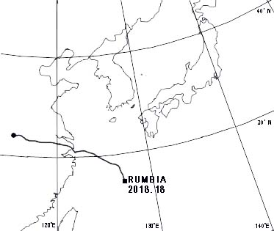
Fig. 1 Track of TS RUMBIA (1818)
TS RUMBIA(1818), upgraded to TS in the Northwest of the Okinawa at 03:00 UTC on 15 August, moving Northwestward, landed in China continent and transformed into an extra tropical cyclone around 00:00 UTC on 18August.
As a result of moving to the Korean West Sea, 20-21 August, it rained nationwide, especially, Average precipitation of 102mm was recorded in North PyongAn Province.
- TS SOULIK (1819), affected directly
SOULIK was upgraded to TS in the northwest of the GUAM at 00:00 UTC on 16 August.
It moved northwestward and had intensity with sustained maximum winds of 86KT and central pressure of 950hPa 5-days later.
SOULIK, turning northwestward slowly, made landfall and transformed into extra tropical cyclone 18-hours later.
Average precipitation was 86mm nationwide due to TS SOULIK. Especially, average precipitation was more than 400mm in WonSan bay, KangWon province.
During TS SOULIK was passing through our country, it was mainly recorded strong wind of 10-17 m/s in several areas including eastern coast.
Our meteorologists told that the reason is interaction of 2 typhoons.
SIMARON, not influenced directly on DPRK, upgraded to TS on 18 August and moved very quickly to northward, had formed a circulating system with SOULIK, it had resulted the continuous flow of warm and wet air from southward.

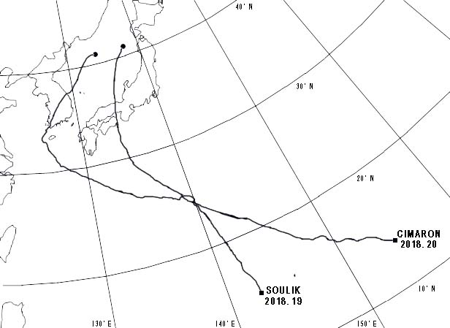
Fig 2. Track of TS SOULIK(1819) and CIMARON(1820)
- Hydrological Assessment
DPRK has been affected by Ts SOULIK in 2018.
In relation to the typhoon impact, several basins in DPRK had extra-large heavy rainfalls on 29 August, and historical flood has been occurred in the middle and lower reachs of Ryesong River, located in middle region in DPRK.
The average precipitation in the basin was 349mm (especially 137mm in GuRak, 364mm in PyongSan, 410mm in ToSan, 664mm in KumChon and 572mm in YonBak Lake) and it caused historical flood. The maximum precipitation for 1-hour was 127mm in KumChon County and 142mm in YonBak Lake, and these were the maximum precipitation in observation history.
Generally, the peak in stream flow had been observed after 10 to 13 hours from maximum rainfall but the rainfall had been concentrated in the middle and lower reachs of RyeSong River, and therefore had been occured a flood with peak flow after only 3 hours from maximum rainfall.
SHMA issued pre-forecast before 24 hours and special warning messages every one hour before 12 hours to the relevant agencies and residents.
But, since historical flood of 300 cyclic years, water level in YonBak Lake had been rissen 3.8m higher than normal, So a lot of farmland were inundated and public buildings and houses were destructed.
The second flood had been occurred at the beginning of July owing to heavy rainfall in the middle reach of Taedong River.
There was a heavy rain more than 249mm in the upstream of Pyongyang city, 166mm in the downstream, 295mm in the Basin of Biryu River, tributary of Taedong River from 03:00(UTC) 9 July to 04:00(UTC) 11 July.
Threrfore, water level in Taedong River had been rissen over promenade on 22:00(UTC) 10 July at the Taedong Bridge.
Flood like this event may occure every 15 years, and flood over this event had been occured in 1990, 2007 and 2009 since 1967.

- Socio-Economic assessment
In recent years, DPRK have been continuously affected by typhoon, and suffered from typhoon-related disasters.
In this year, there was a heavy rain more than 100mm per one hour by TS SOULIK in areas of Wonsan Bay KangWon Province.
Especially, there was a torrential rain more than 502mm for 12 hours in MunChon city Kangwon Province, it was the second record as maximumprecipitation (517mm on 26 July 2011) in our country.
Warning had been issued 3 days ago, provincial and municipal governments had taken measures to minimize damage from typhoon

- Regional Cooperation Assessment
Typhoon Committee makes an important contribution to prevent Typhoon-related disasters in DPRK.
It is very important to enhance international cooperation for preventing disasters due to typhoon and maintaining economic continuous increases.
Typhoon information issued form RSMC Tokyo Typhoon Center, and numerical weather forecasting products of ECMWF, CMA, JMA, and NCEP have been received via GTS, Internet, and CMAcast and used for typhoon monitoring and forecasting in DPRK.
In the future, it is very important that accuracy and promptness of typhoon information issued in typhoon warning center should be improved.
Also, we think that STI’s friendship is a good model for regional cooperation.
SHMA wishes that Typhoon Committee has a great success in his future work.

Ⅱ. Summary of progress in Key Result Area
- Improvement of typhoon forecasting and warning system
Main Text:
Recently, Typhoon Operational Prediction System 2.0(TOPS 2.0) has been used widely.
Using this system, we made synoptic analysis on typhoon forecasting products of each country, and we used to found best-track data for typhoon.
Typhoon forecasting results have been issued to the relevant agencies and the public by mass media including TV, radio, computer network, cellphone and so on.
Identified opportunities/ challenges, if any, for future development or collaboration:
We are trying to increase accuracy of typhoon
Priority Areas Addressed:
Enhance the capacity to monitor and forecast typhoon
Contact Information:
Member: Democratic People’s Republic of Korea
Name of contact for this item: Choe Kyong Sik
Telephone:
Email:shma@star-co.net.kp

- Improvement of Typhoon Information service
Main text:
As increasing of social interest to typhoon forecasting, SHMA pays a great attention to the improvement of information services in DPRK.
As a rapidly increasing natural disaster due to typhoon, it is very important to strengthen public awareness.
For this, meteorologists have disseminated the detailed information on typhoon to the public via TV or Radio and newspaper.
SHMA will promote the improvement of typhoon information service in the future.

Identified opportunities/ challenges, if any, for future development or collaboration:
To increase public awareness
Priority Areas Addressed:
Enhance the capacity to monitor and forecast typhoon
Contact Information:
Member: Democratic People’s Republic of Korea
Name of contact for this item: Ri Yong Nam
Telephone:
Email:shma@star-co.net.kp

